Veränderte Tabellen:

create table person(**pnr_pratljacic** integer primary key, pname varchar2(20));

create table country (**country_id_pratljacic** integer primary key, country_name varchar2(20));

create table calls(**call_nr_pratljacic** integer, pnr integer references person(pnr_pratljacic),

country_id integer references country (country_id_pratljacic),

duration integer,

call_date date);

Select Kommandos:

1. select sum(duration), decode(grouping_id(pname),1,'all P.', pname) as currentperson, decode(grouping_id(country_name),1,'all C.', country_name) as currentcountry, decode(grouping_id(to_char(call_date, 'YYYY')),1,'all Y.', to_char(call_date, 'YYYY')) as currentyear from calls c join person p on c.pnr = p.pnr_pratljacic join country cntry on c.country_id = cntry.country_id_pratljacic group by cube(pname, country_name, to_char(call_date, 'YYYY'));
2. select to_char(call_date, 'MM') as changemonth, duration, duration - first_value(duration) over (order by calls.call_date rows between 1 preceding and 0 following) as changetotal, first_value(duration) over (order by calls.call_date rows between 1 preceding and 0 following) beforechange from calls where country_id = (select country_id_pratljacic from country where country_name = 'Austria') AND to_char(call_date, 'yyyy') = 2017;
3. create view minchangeview as select to_char(call_date, 'MM') as changemonth, duration, first_value(duration) over (order by calls.call_date rows between 1 preceding AND 0 following) as beforechange, duration - first_value(duration) over (order by calls.call_date rows between 1 preceding and 0 following) as totalchange from calls where country_id = (select country_id_pratljacic from country where country_name = 'Austria') AND to_char(call_date, 'YYYY') = 2017;  
     
   select * from minchangeview where totalchange = (select min(totalchange) from minchangeview);  
     
   drop view minchangeview;
4. create view rankview as select dense_rank() over (order by duration desc) as currentrank, pname, country_name, duration from calls c join country cntry on c.country_id = cntry.country_id_pratljacic join person p on p.pnr_pratljacic = c.pnr group by country_name, pname, duration order by country_name, currentrank;  
     
   select * from rankview where currentrank < 3;  
     
   drop view rankview;

Ergebnisse:

1. 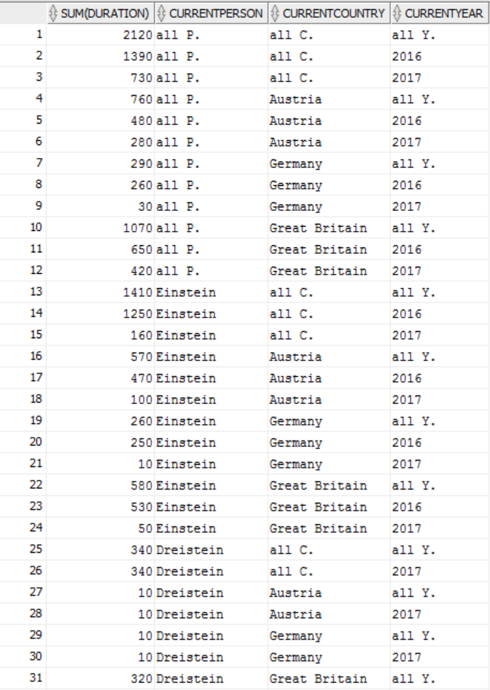  
   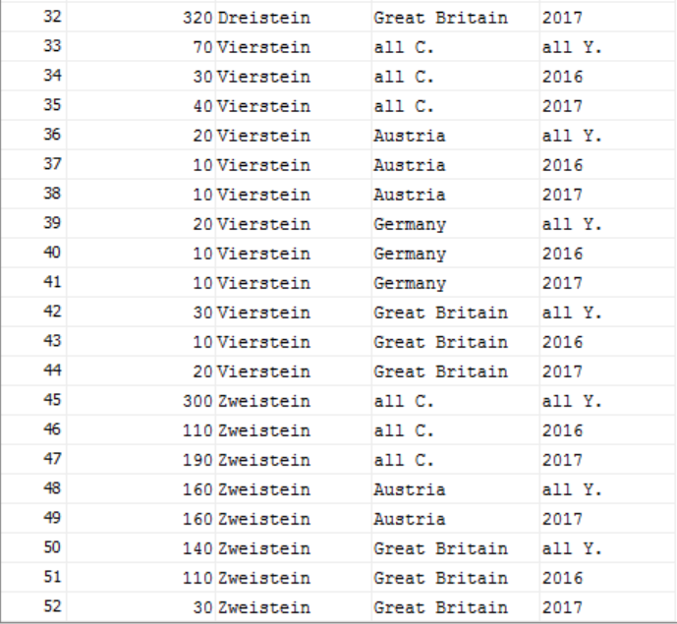
2. 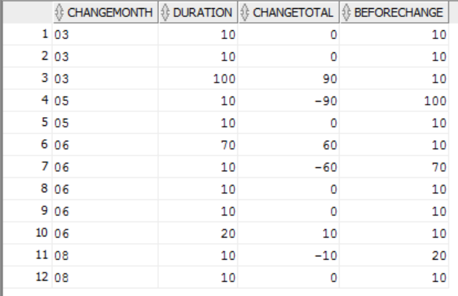

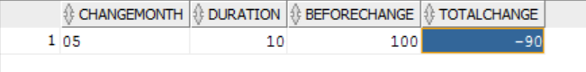

1. 